Android App Storyboards

Design if Correct Answer

Main Design Blank

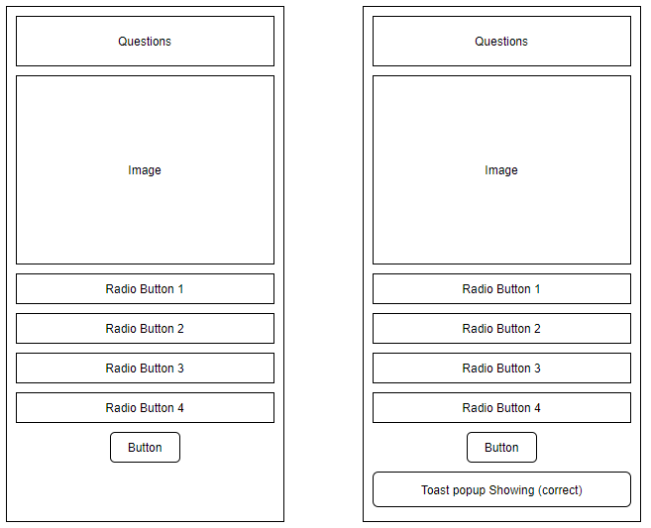

Results Page Design

Design if incorrect answer

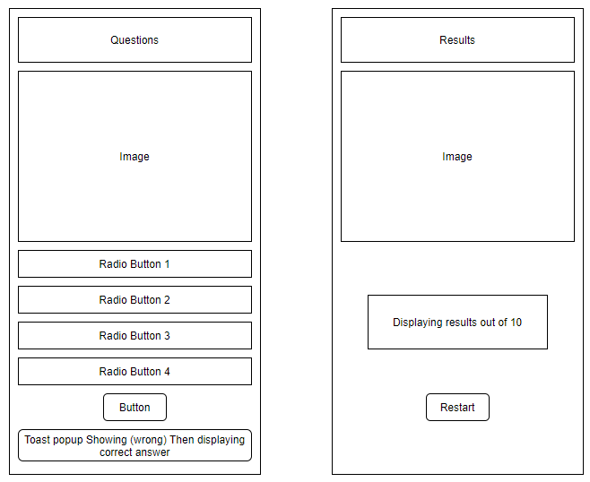

Design Features

* I used large text font, so it was easy for the user to read.
* I made sure the radio buttons were easy to press and easy to see which one is selected.
* I made a toast pop up if the user presses the submit button when nothing is selected so that the user can not accidentally skip a question.
* I made sure my images were a decent quality and size so they are easy for the user to view.